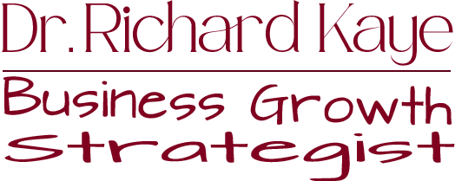

Meet Dr. Richard Kaye: The Maestro of Business Acceleration!
For over two decades, Richard has been the driving force behind the success stories of countless entrepreneurs, propelling them to unparalleled growth. His secret weapon? Profitable, powerful publicity that transforms businesses from early-stage infancy to revenue-rich maturity.
Dr. Kaye isn't just a consultant; he's a trailblazer in the world of business evolution. A sought-after guest on podcasts and webinars, he's left his mark on radio and television programs, gracing screens on KGTV in San Diego and KTLA in Los Angeles. Forbes Magazine has acknowledged his expertise, and PBS featured a special that showcased the profound impact of his work.
As the creator of the esteemed "The Secrets of Empowering Negotiation" program, Kaye has imparted his wisdom through workshops and seminars around the globe, from the vibrant landscapes of Australia to the cultural richness of France, the innovation hub of Japan, and the vast expanse of Russia.
Sharing stages with luminaries such as Lisa Nichols, Mark Victor Hansen, Rev. Michael Beckwith, Sharon Lechter, and Forbes Riley, Kaye earned the Lifetime Achievement Award from the Top Talent Agency. His influence extends beyond borders as he served on a Non-Governmental Organization (NGO) within the United Nations and contributed to the boards of for-profit companies.
A founding member of the Taos Entrepreneurial Network (TEN) and a former vice president of CEO Space, Kaye's commitment to community building is as strong as his dedication to business excellence.
The author of the critically acclaimed book, "The Secrets of Creating Customers for Life," Kaye doesn't just preach success; he lives it. Nestled in the artistic haven of Taos, New Mexico, he shares his life with his wife, Angel, continuing to inspire and shape the future of entrepreneurs worldwide.
Kaye continues to keep his presence on the pulse of leading-edge business when he recently conducted an enlightening interview with Dr. John Demartini for the Neuroscience Summit produced by the Los Angeles Tribune.
Ready to unlock the secrets of success? Follow the journey of Dr. Richard Kaye as he redefines the landscape of business growth and propels entrepreneurs toward the summit of their aspirations.

